JAYAPRAKASH NARAYAN COLLEGE OF ENGINEERING DHARMAPUR, MAHABUBNAGAR-509001
AFFILIATED TO JAWAHARLAL NEHRU TECHNOLOGICAL UNIVERSITY,
KUKATPALLY, HYDERABAD – 500072, Telangana, India

“LIFELONG LEARNING OF LARGE LANGUAGE MODEL

BASED AGENTS: A ROADMAP”

A Dissertation on Major Project submitted to the Jawaharlal Nehru Technological University, Hyderabad in partial fulfilment of the requirement for the award of degree of

MASTER’S DEGREE IN
MASTER OF COMPUTER APPLICATIONS

Submitted by
G. JAYANTH KRISHNA (24361F0003)
Under the Guidance Mrs.A.Swathi Asst. Professor

SEPTEMBER 2026
Department of Master of computer Applications


JAYAPRAKASH NARAYAN COLLEGE OF ENGINEERING DHARMAPUR, MAHABUBNAGAR – 509001
Web: www.jpnce.ac.in, Phone:
8886680021 2024-2026

I
DEPARTMENT OF MASTER OF COMPUTER APPLICATIONS

JAYAPRAKASH NARAYAN COLLEGE OF ENGINEERING

DHARMAPUR, MAHABUBNAGAR – 509001
(Affiliated to J.N.T.U, Approved by A.I.C.T.E)

CERTIFICATE

This is to certify that Major Project report on “LIFELONG LEARNING OF LARGE LANGUAGE MODEL BASED AGENTS: A ROADMAP”, is a Bonafide work done
by G. JAYANTH KRISHNA(24361F0003). In partial fulfilment of the requirement of the award for the Master’s Degree in “Master of Computer Applications ” , J.N.T.U, Hyderabad during the year 2024-2026.

Project Guide Incharge

Mrs. A.Swathi Mrs.A. Swathi
Asst. Professor, Asst. Professor,
Dept of MCA. Dept of MCA.

External Examiner

Mrs. A.Swathi Assistant Professor

II

Department Of Master of Computer Applications Jayaprakash Narayan College Of Engineering Mahabubnagar– 509001, Telangana,India.

Department Of Master of Computer Applications Jayaprakash Narayan College Of Engineering, Mahabubnagar.

05.09.2026

Supervisor’s Certificate

This is to certify that the work in the thesis entitled by “LIFELONG LEARNING OF LARGE LANGUAGE MODEL BASED AGENTS: A ROADMAP”
G. JAYANTH KRISHNA is a record of a work carried out under my supervision and guidance in partial fulfilment of the requirements for the award of the degree of Master’s Degree in Master of Computer Applications.

(Mrs. A.Swathi) Supervisor

III

ACKNOWLEDGMENT

We owe a debt of gratitude to Mrs. A.Swathi, Assistant Professor, MCA, JPNCE for her admirable guidance and inspiration both theoretically and practically, and most importantly for the drive to complete projects successfully. Working under such an eminent guide was our privilege.
We express my sincere thanks to A.Swathi , Incharge, MCA, JPNCE for all kinds of consideration, support, and encouragement in carrying out this project successfully.
We would also like to thank P.KRISHNA MURTHY, Principal, JPNCE for his cooperation and encouragement.

We are grateful to the department of Master of Computer Applications for providing us with excellent lab and library facilities.

We thank our parents for the love, care, and moral support without which I would have not been able to complete this project. It has been a constant source of inspiration for all my academic endeavors.

PROJECT ASSOCIATE

G. JAYANTH KRISHNA (24361F0003)

IV

ABSTRACT

A key component of increasing Artificial General Intelligence (AGI) is lifelong learning, which also goes by the names constant learning and incremental learning. It allows systems to continually adapt to settings that are always changing. Although LLMs have shown great promise in NLP, the current agents trained on LLMs are often static and ill-equipped to deal with dynamically changing environments. To our knowledge, this is the first comprehensive review of the methods that may be used to provide LLM-based agents with the ability to learn throughout their lives. We group these agents' fundamental parts into three sections: the perception section, which integrates multimodal inputs, the memory section, which stores and retrieves information as it evolves, and the action section, which allows for grounded interactions with the ever-changing world. We emphasise the ways in which these foundational elements work together to increase performance over the long run, prevent catastrophic forgetting, and allow for ongoing adaptability. Researchers and practitioners in the field of lifelong learning agent development may use this survey as a guide, as it sheds light on current trends, future directions, assessment criteria, and potential use cases.
ARGUMENT FOR ABSTRACT
Agents built on Large Language Models (LLMs) are becoming more common as smart systems with the ability to think, plan, comprehend plain language, and collaborate with other tools to accomplish complicated tasks. Traditional LLM-based agents, on the other hand, can only learn from static datasets and can't learn new things, remember what they've learned, or adjust to new conditions as they go. Because of this shortcoming, they struggle to adapt to ever-changing contexts that need constant learning due to factors such as fresh data, changing user needs, and new domains. To overcome this obstacle, LLM-based agents may use lifelong learning strategies, which allow them to gradually absorb new information while retaining what they already know and reducing the likelihood of catastrophic forgetting. Adaptive reasoning, human feedback, knowledge management, retrieval-augmented generation, reinforcement learning, ongoing learning, memory architectures, and lifelong learning LLM-based agents are all part of this roadmap's complete framework.

V

CONTENTS

SNO | CHAPTER |  | PAGENO
 | CERTIFICATE |  | I
 | ACKNOWLEDGME | NT | III
 | ABSTRACT |  | IV
 | CONTENTS |  | V
 | LIST OF FIGURES |  | VI
1 | CHAPTER–1 INTRODUCTION |  | 1
 | 1.2 Literature Review |  | 1
2 | CHAPTER–2 SYSTEM ANALYSIS |  | 3
3 | CHAPTER–3 METHODOLOGY |  | 4
4 | CHAPTER–4 TOOLS / HARDWARE & SOFTWARE REQUIREMENTS |  | 5
5 | CHAPTER–5 IMPLEMENTATION & SYSTEM DESIGN |  | 6
6 | CHAPTER–6 ALGORITHMS & SYSTEM STUDY |  | 20
7 | CHAPTER–7 PSEUDO CODE & TEST CASES |  | 22
8 | CHAPTER–8 RESULTS |  | 33
9 | CONCLUSION |  | 39
10 | REFERENCES |  | 40

VI

LIST OF FIGURES

FIGURE NO: | FIGURE DESCRIPTION |  | PAGE N0:
Figure 5.3.1 | SYSTEM ARCHITECTURE |  | 7
Figure 5.4.1 | USE CASE DIAGRAM |  | 11
Figure 5.4.2 | CLASS DIAGRAM |  | 12
Figure 5.4.3 | SEQUENCE DIAGRAM |  | 13
Figure 5.4.4 | ACTIVITY DIAGRAM |  | 14
Figure 5.4.5 | COLLABORATION DIAGRAM |  | 15
Figure 5.4.6 | COMPONENT DIAGRAM |  | 16
Figure 5.4.7 | DEPLOYMENT DIAGRAM |  | 17
Figure 5.4.8 | STATE MACHINE DIAGRAM |  | 18
Figure 5.4.9 | ER DIAGRAM |  | 19

CHAPTER-1

INTRODUCTION & LITERATURE REVIEW

INTRODUCTION
Developing intelligent systems that can adapt to new tasks and settings while continually acquiring, integrating, and retaining information is a key competency. One such capability is lifelong learning, which is sometimes called ongoing or incremental learning. In contrast to traditional ML systems, which are often trained on static datasets for predefined tasks, LL systems are built to adapt and improve with time, gaining new information while retaining what they already know. A significant obstacle to accomplishing this goal is the stabilityplasticity problem, which occurs when one must decide how much to remember and how well to adapt to new information and activities.
Large Language Models (LLMs) have recently made great strides, greatly enhancing the interpretation, reasoning, and creation of natural language. But conventional LLMs can't learn from their mistakes or adjust to new circumstances without regular updates or retraining, so they stay mostly the same after deployment. Agents built on LLM, on the other hand, are able to interact with their external contexts, thereby expanding the possibilities of traditional language models. These beings are capable of multi-sensory perception, memory retention, tool usage, and action in response to environmental input. This renders them well-suited for ever-changing uses including operating systems, robotics, online commerce, gaming, navigation, and interactive assistants.
A better technique to create intelligent systems that can adapt and operate on their own is to combine lifetime learning with agents that are based on LLM. A lifetime LLM agent may gain knowledge by its interactions and experiences, apply what it has learned, and become better at solving more difficult problems over time. Such an agent may learn from its past mistakes and adjust its actions accordingly, rather than needing a whole overhaul or meticulously crafted instructions every time the job or environment changes.
me and work well in situations that are complex, dynamic, and constantly changing.

1.2. A GROUP OF REVIEWS
1. AI That Requires Lifelong Learning Penelope Hoiem and Zhizhong Li Brief summary:
Here, we look at the possibility of AI systems engaging in "lifelong learning," or the process of constantly acquiring new knowledge while retaining what they already know.
Conventional machine learning models lack the flexibility to continue learning even after being deployed, since they are often trained on static datasets. One way that models may adapt to new jobs and situations is via lifelong learning, which aims to circumvent this constraint. Catastrophic forgetting, in which the model loses previously acquired knowledge upon learning new information, is one of the main issues. Methods that enable models to juggle acquiring new information with retaining old knowledge are the focus of this study. A common way to express this equilibrium is as the stability-plasticity dilemma. Autonomous AI systems that function in dynamic situations greatly benefit from lifelong learning. Such systems must be able to recall and apply past experiences to future challenges. Mechanisms in the brain's memory may aid in the storage and retrieval of crucial information. Lifelong learning tactics like this may help modern big language model agents. The surroundings, past interactions, and successful and unsuccessful behaviours may all be recorded by an LLM agent. Better decisions in the future will be possible as a result of these experiences. This study lays the groundwork for future AI bots to learn and adapt on the fly.
Interactive Simulations of Human Behaviour: Generative Agents Michael S. Bernstein, Percy Liang, Joon Sung Park, Meredith Ringel Morris, Carrie Jun Cai, and Joseph O'Brien are the authors.
Brief summary:
Generative Agents, first proposed by Park et al., employ massive language models to generate agents capable of mimicking human behaviour. The suggested agents have good memory and may draw on their experiences to guide their decision-making in the future. Important observations from interactions are recorded by the system using a memory architecture. Additionally, it makes use of a reflective process to elevate one's understanding of their own experiences. Whenever an action or reaction is required, the agents access the appropriate memories. They are able to keep their behaviour consistent throughout time because of this. Memory is crucial in intelligent agent systems, as the study shows. Additionally, it demonstrates the application of LLMs in the development of agents capable of interacting with dynamic settings. The method offers practical suggestions for ongoing improvement via learning and change. Because agents may learn from their mistakes and do better in the future, this study has important implications for LL.

CHAPTER-2

SYSTEM ANALYSIS

EXISTING SYSTEM
Modern agents built on Large Language Models (LLMs) are very good at comprehending natural language, reasoning, creating content, and automating tasks. In most cases, these systems rely on foundation models that have already been trained using massive datasets and adjusted for use in subsequent processes. The performance of modern LLM agents is enhanced in many fields, including education, healthcare, software development, customer assistance, and scientific research, by integrating components such as external tool utilisation, conversational memory, retrieval-augmented generation (RAG), and quick engineering. Notwithstanding these improvements, most LLM-based agents still depend on static information learned during pre-training and have limited room for improvement in terms of fine-tuning. After being deployed, it may be somewhat costly to retrain them so that they can continue to learn from new events and adapt their expertise. Access to up-to-date external information is made possible via retrieval-based approaches, but the model's internal knowledge and reasoning skills are not fundamentally changed. In addition, the majority of existing systems are deficient in long-term memory processes that would enable them to learn from their mistakes, improve their decision-making abilities, and tailor their interactions to each individual user. Therefore, they have difficulties while functioning in situations that are constantly changing and characterised by evolving knowledge, user needs, and contextual information.
The Current System's Drawbacks Current agents that use LLM mostly rely on static pretrained information and are unable to continually update their own knowledge after they are deployed. It is computationally costly and time-consuming to retrain with huge datasets often. When new information is added via fine-tuning, the models might be catastrophically forgotten.

CHAPTER-3

METHODOLOGY
An artificial intelligence agent may be trained to learn and adapt from fresh data, user interactions, feedback, and adaption events according to the proposed Lifelong Learning of Large Language Model (LLM)-Based Agents technique. Management of datasets, text preprocessing, feature extraction and selection, training of baseline models, comparison of algorithms, user interaction, collection of feedback, and continual adaption are all part of the system.
"Continuous Learning and Adaptation of LLM-Based Agents" is the name given to the system in the uploaded implementation. It boasts three main features: Admin Training, FileBased Responses, and Continuous Adaptation. 1. Initialising the System In the initial step, the learning infrastructure and LLM-agent environment are set up. Users may communicate with the trained agent using the system's web-based interface, which also allows administrators to manage datasets and models.
The building's framework includes: Managerial user interface Administration of datasets Preprocessing of text Extracting and selecting features Developing a model Comparing algorithms The engagement of users Collecting feedback The process of adaptation Answering questions via files Background of the discussion Core features of the system are highlighted on the home page: Admin Training, File-Based Responses, and Continuous Adaptation.
Step 2: Authentication for Administrators An administrator's login controls access to the system's training and management features. To access the administration dashboard, administrators must first authenticate using the login portal.
Validation aids in disentangling: management of models and data Procedures for training Managing adaptation Common user engagement resulting from everyday user tasks.

CHAPTER-4

TOOLS/ HARDWARE & SOFTWARE REQUIREMENTS
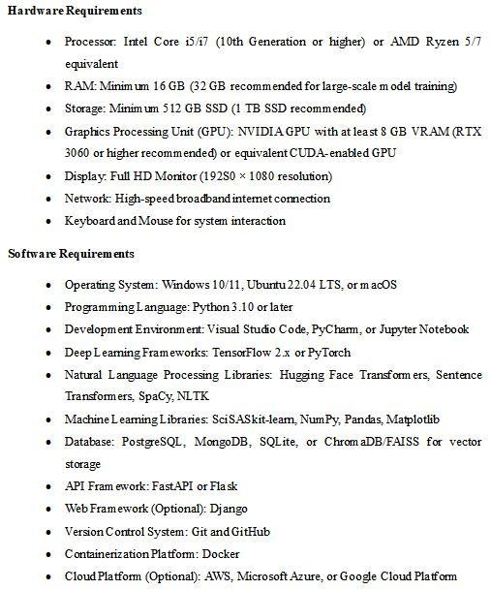

CHAPTER-5

IMPLEMENTATION & SYSTEM DESIGN

IMPLEMENTATION AND MODULES
An intelligent lifelong learning framework for agents based on Large Language Models (LLMs) is created by the suggested system. An AI agent may develop its decision-making skills, adapt to new tasks, learn from interactions, retain beneficial experiences, and gain new information continually with the help of this framework.
The suggested framework incorporates adaptive reasoning, memory management, continuous learning, knowledge updating, experience reuse, and fixed pretrained information, in contrast to traditional LLM-based systems that primarily function with fixed pretrained knowledge. These features are designed to facilitate the development of autonomous agents over the long run.
1. Module for Interaction with Users and Task Input Here, users may interact with the system by entering enquiries, tasks, objectives, or instructions that the LLM-based agent can then process.
Purpose : Take in enquiries from users.
Get directions for assigned tasks Please determine the objectives of the user. Review the needs of the job. Carry out requests to the intelligent companion.
Agent Processing follows Task Understanding after input.
2. Intent Analysis and Task Understanding Module To comprehend the task's meaning and purpose, the system use its Natural Language Processing and LLM capabilities.
Purpose : Identification of purpose Making sense of the situation Decomposing tasks. Extracting goals Analysing what is needed In order for the agent to process user instructions, this module organises them into organised tasks.
Module for Intelligent Agents Based on LLM The suggested system revolves around this central element. The Big Language Model is in charge of all the thinking and deciding.
7

SYSTEM DESIGN
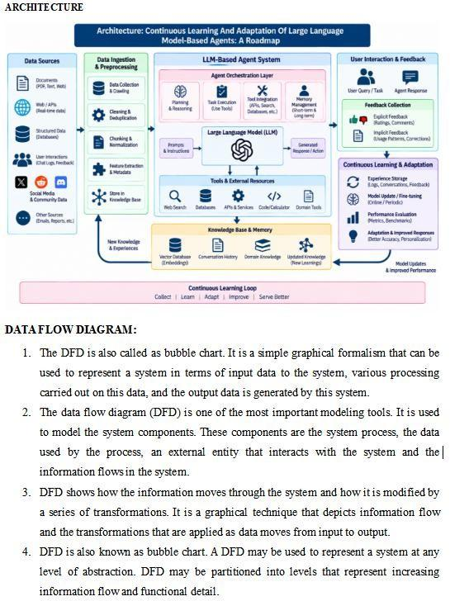
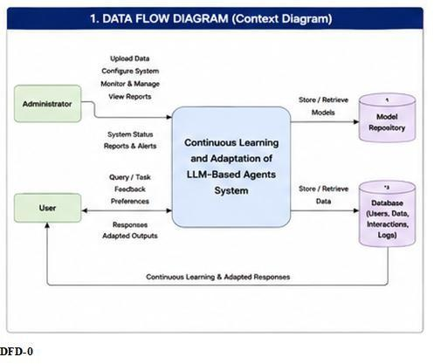
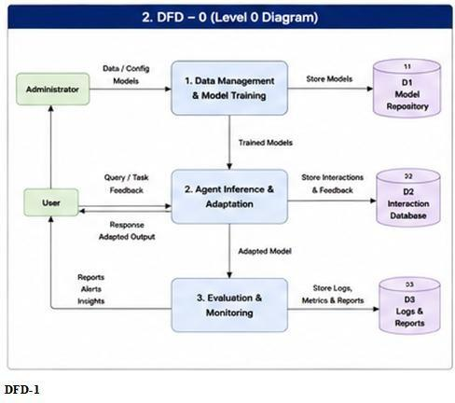
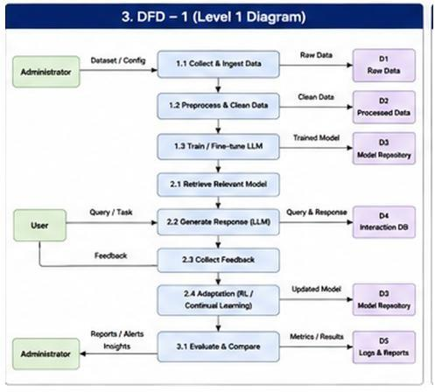

UML DIAGRAMS
"Unified Modelling Language" is what UML stands for. Object-oriented software engineers rely on UML, a standardised general-purpose modelling language. The Object Management Group is in charge of the standard and was responsible for its creation.
A standard language for modelling object-oriented computer software is the aim of the Unified Modelling Language (UML). A meta-model and a notation are the two main parts of UML as it stands right now. It is possible that UML may be supplemented or linked with other methods or processes in the future.Any system, not only software, may have its artefacts specified, visualised, constructed, and documented using the Unified Modelling Language. This includes business models as well.
When it comes to modelling big and complicated systems, the UML is a compilation of the greatest technical approaches that have worked.
Both the software development process and object-oriented software development rely heavily on the Unified Modelling Language (UML). The UML is a software project design language that primarily makes use of visual notations.
intended outcomes:
The following are the main objectives that guided the development of the UML:
1. Offer users a visual modelling language that is both expressive and ready-to-use, allowing them to create and share models that matter.
Second, make the fundamental ideas more versatile by include methods for specialisation and extendibility.
Stand on your own two feet in terms of development methodology and programming languages.
Fourth, lay down the rules so that everyone can comprehend the modelling language. Promote expansion of the market for OO tools.
Sixth, back up more advanced ideas in programming including frameworks, components, collaborations, and patterns.
7–Incorporate industry standards.
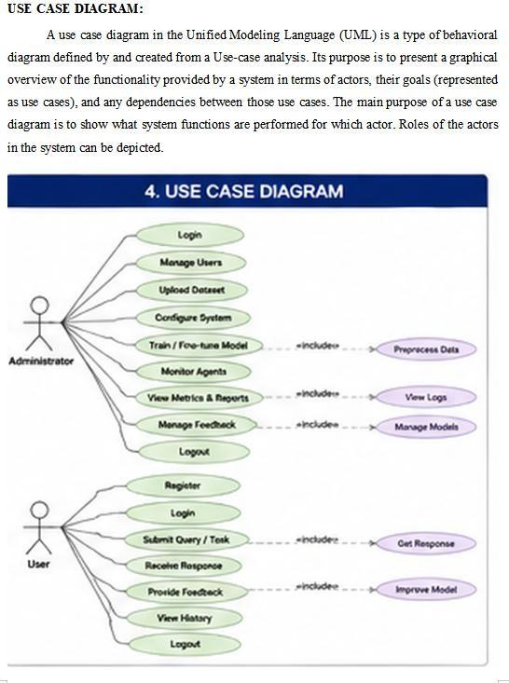
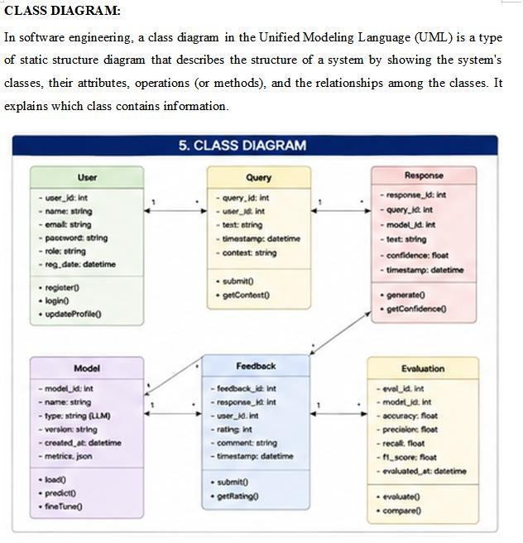
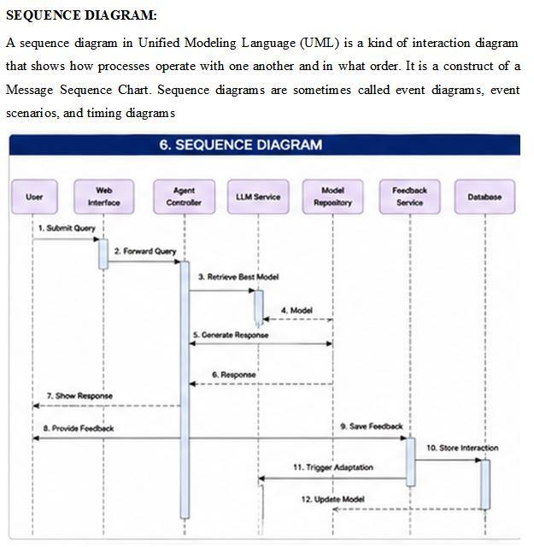
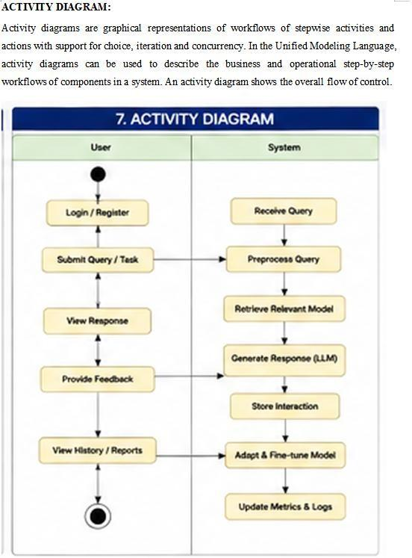
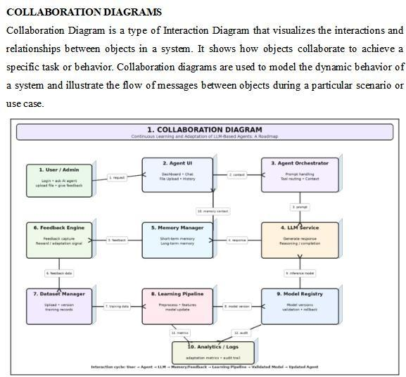
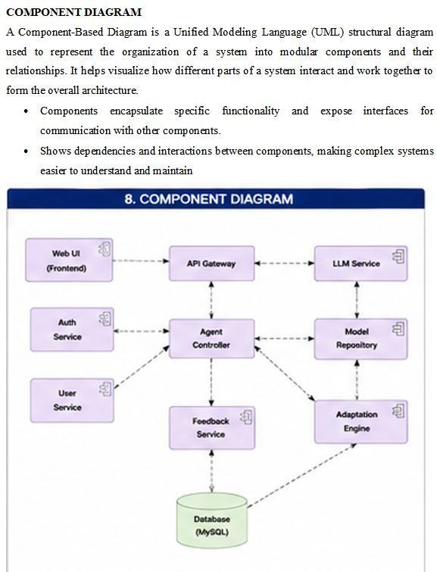
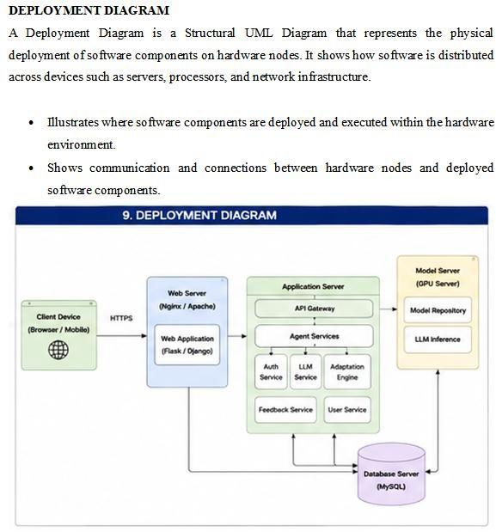
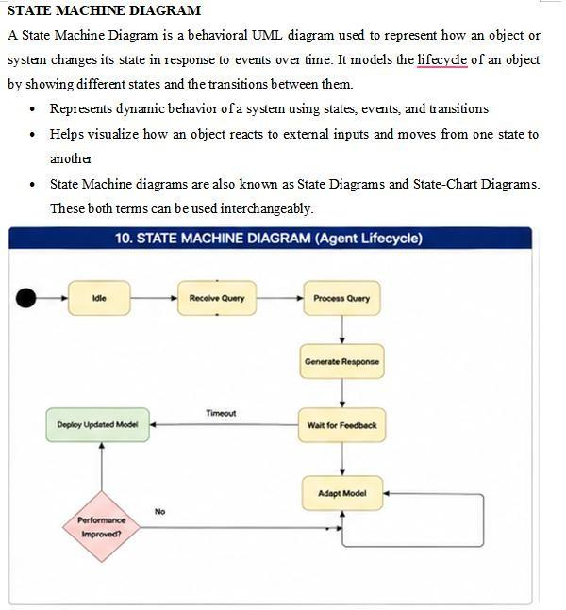
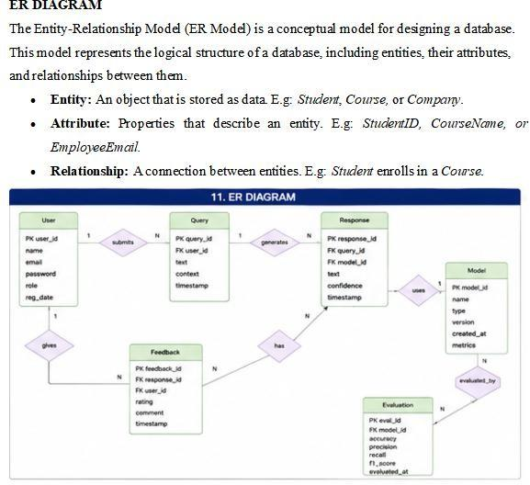

CHAPTER-6

ALGORITHMS & SYSTEM STUDY

ALGORITHMS
"Continuous Learning and Adaptation of Large Language Model-Based Agents: A Roadmap" is the title of the suggested system. Tasks such as managing datasets, preparing texts, selecting features using TF-IDF and Chi-Square, training models, answering questions based on documents, storing user comments, adapting continuously, and using memory are all part of the implementation.
1. Generalised Linear Modelling Text or learnt knowledge categories may be first classified using a supervised machinelearning algorithm. What to do:
Step one: transform text into feature vectors using TF-IDF.
Step two: hone the Logistic Regression algorithm.
Third, figure out the chances of each class.
Figure out which output class is most likely.
2. A Naïve Bayes Multinomial An method that is optimised for text-based datasets using probability theory.
What to do:
Obtain characteristics based on word frequency or TF-IDF.
Second, figure out the odds of certain outcomes.
Third, use Bayes' theorem.
Identify the most probable category.
3. A Random Forest An method for ensemble learning that uses a combination of decision trees.
What to do:
Make a number of decision trees.
Use various samples to train each tree.
Gather forecasts from every tree.
To find the end outcome, use the majority vote.
4. A Support Vector Machine that Uses Linear Data (Linear SVM) To divide text into its respective groups, linear SVM determines the best hyperplane. What to do:
First, transform the text input into number attributes.
Step two: teach the support vector machine classifier...
Find the decision boundary with the biggest margin.
Identify the correct category.
These four trained algorithms are shown in the project interface on pages 5-7, along with a comparison of their performance using Accuracy, Precision, Recall, and F1-Score. An Algorithm for Adaptive Memory and Continuous Learning The core idea is an LLM-based agents continuous learning framework that integrates: Array of Information "Preprocessing Text"
TF-IDF Extracting Features Selected Features via Chi-Square Analysis Retrieval of Knowledge from Files Alternate Recollection Customer Opinion Maintaining a Change Investigation of the System and Feasibility This phase involves analysing the project's viability and putting out a business proposal with a high-level strategy and estimated costs. Conducting a feasibility assessment of the proposed system is an essential part of system analysis. This will guarantee that the suggested solution won't cost the business too much. To do a feasibility study, one must have a basic grasp of the system's primary needs.
Organisations and decision-makers rely on feasibility studies as a crucial tool for navigating the early phases of project development. These studies assess the practicality and likelihood of success of a proposed undertaking. The technical, financial, operational, and strategic merits of a project are all considered in an all-encompassing evaluation.

CHAPTER-7

PSEUDO CODE & TEST CASES
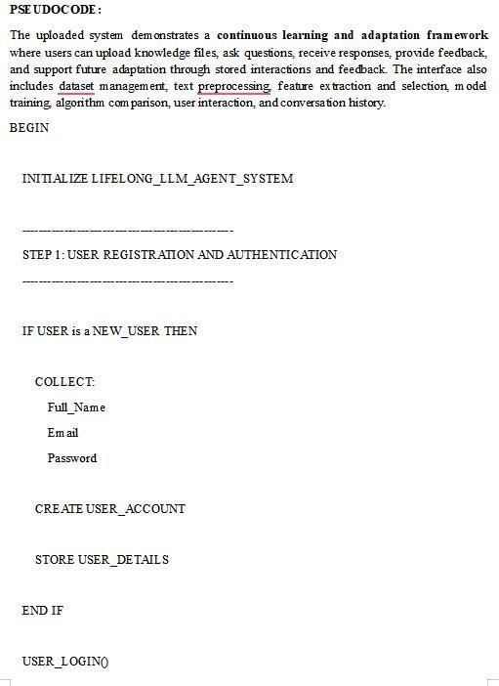
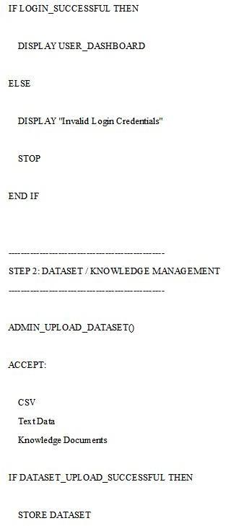
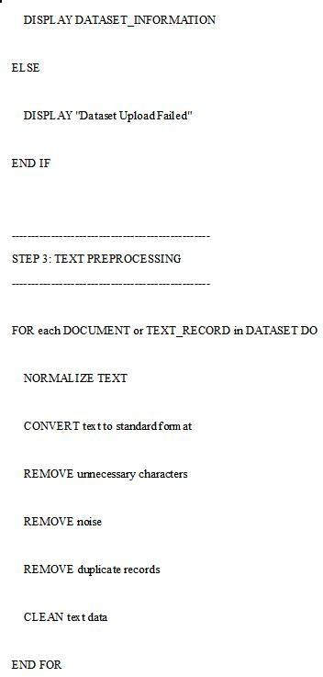
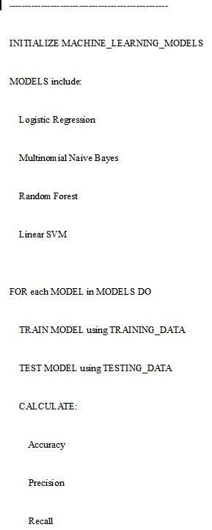
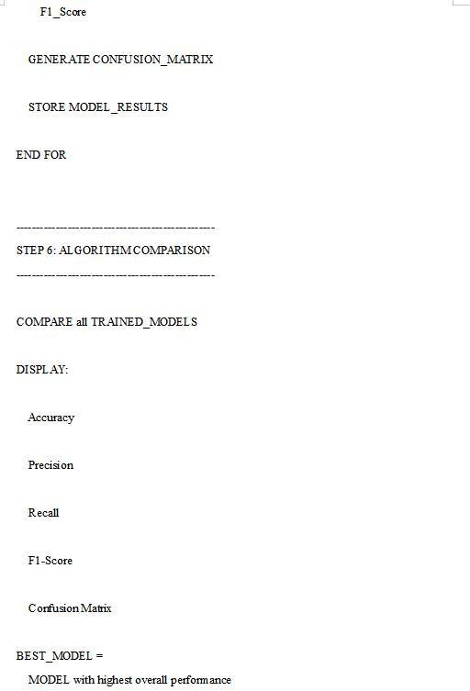
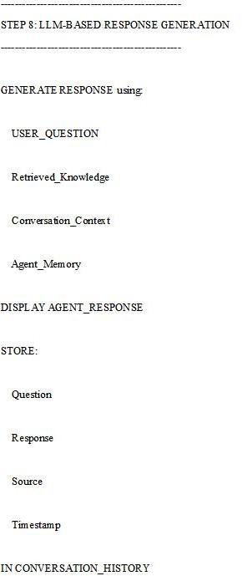
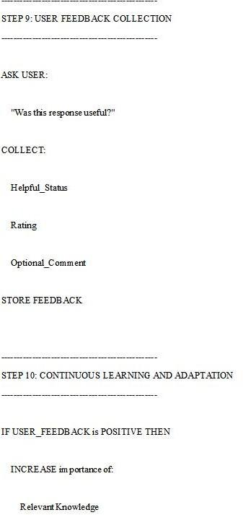
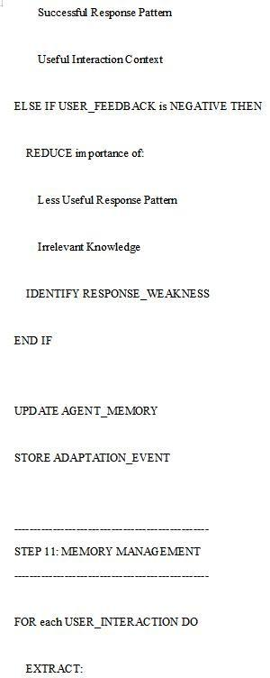
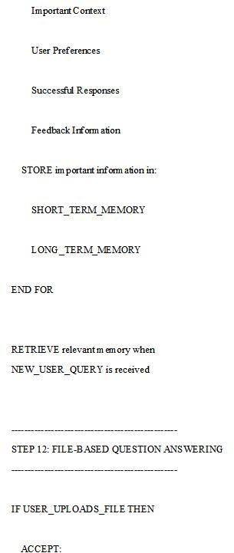
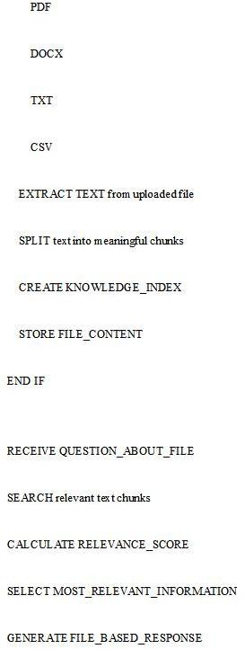
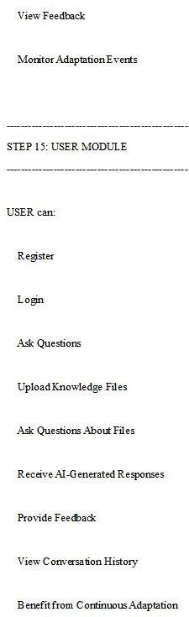

CHAPTER-8

RESULTS
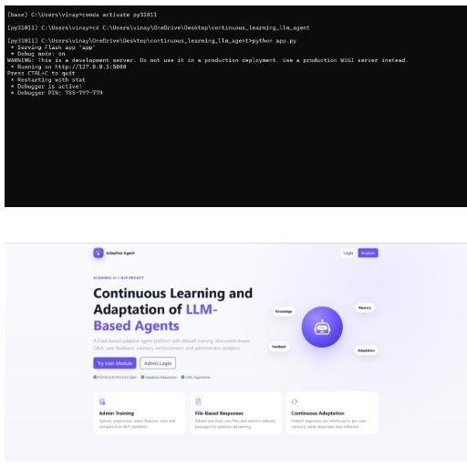
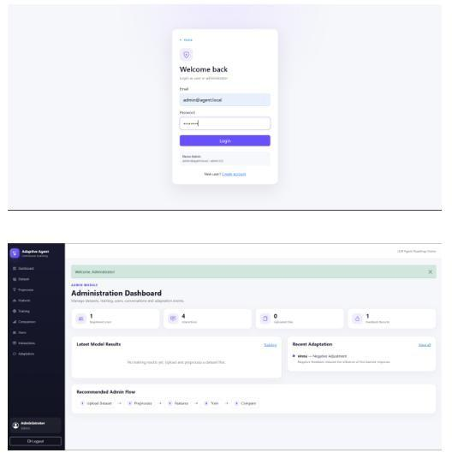
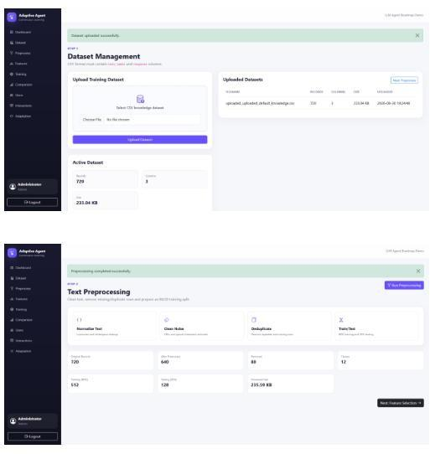
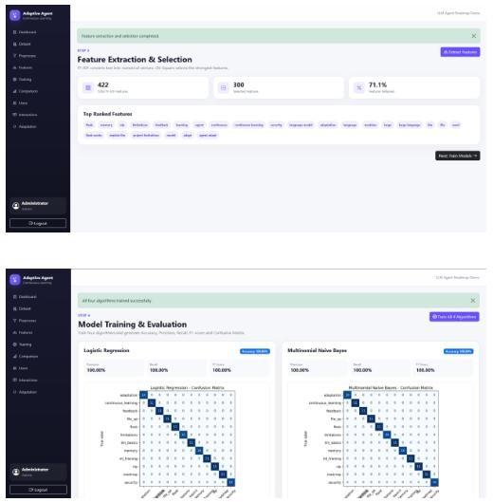
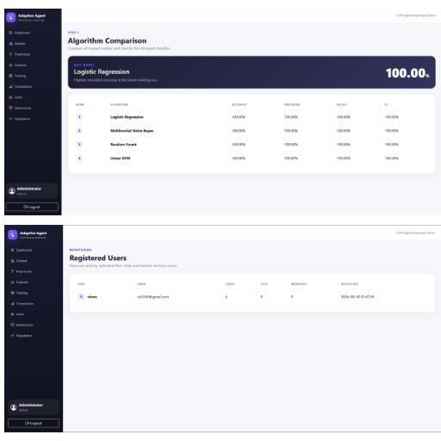
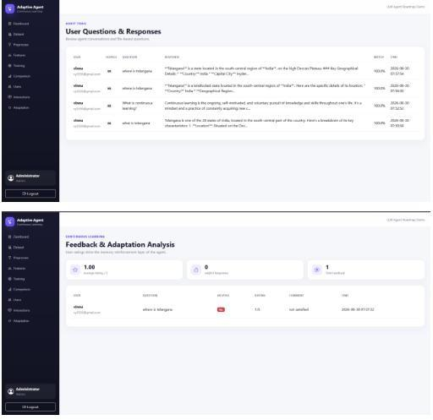

CONCLUSION
Intelligent AI systems that can comprehend natural language, reason, plan, and execute complicated tasks across several disciplines have been greatly impacted by the fast improvement of Large Language Models (LLMs). Nevertheless, current LLM-based agents are unable to continually adapt to new information and evolving settings since they mostly depend on static pre-trained knowledge. Given the constant evolution of information and the frequent changes in user needs, their efficacy in real-world applications is severely limited due to this restriction.
By incorporating continual learning techniques, adaptive memory architectures, parameterefficient fine-tuning, reinforcement learning, and external knowledge retrieval, the proposed roadmap for Life-Long Learning of Large Language Model-Based Agents overcomes these obstacles. Artificial intelligence agents can learn new things in little chunks, remember what they've learned before, avoid catastrophic forgetting, and grow better at reasoning as they interact with the world around them. The suggested framework is even more intelligent, adaptive, and autonomous after adding features like multi-agent cooperation, feedback learning, self-reflection, and short-term and long-term memory.
Scalability, privacy preservation, explainability, ethical AI, and strong assessment procedures are all heavily emphasised in the roadmap as crucial for dependable implementation in realworld settings. The suggested system allows LLM-based agents to adapt over their operational lifespan while maintaining consistency, efficiency, and high-quality decisionmaking by integrating sophisticated learning mechanisms with dynamic knowledge management.
When taken as a whole, the concept of lifelong learning is a giant leap forward in the development of fully autonomous AI systems that can reason, learn, and adapt indefinitely without human intervention. Researchers, developers, and industry practitioners now have a formal framework to build intelligent agents that can learn over time, give individualised support, and improve themselves. With the ongoing advancements in continual learning, memory-augmented architectures, and agentic AI, agents based on life-long learning theory are anticipated to revolutionise various industries such as healthcare, education, cybersecurity, finance, robotics, and scientific research. Ultimately, they will help build AI systems that are more reliable, trustworthy, and focused on humans.

REFERENCES
[1] Brown, T. B., Mann, B., Ryder, N., Subbiah, M., Kaplan, J., Dhariwal, P., et al. (2020). Language Models are Few-Shot Learners. Advances in Neural Information Processing Systems (NeurIPS), 33, 1877–1901.
[2] Devlin, J., Chang, M. W., Lee, K., & Toutanova, K. (2019). BERT: Pre-training of Deep Bidirectional Transformers for Language Understanding. Proceedings of NAACL-HLT, 4171–4186.
[3] Vaswani, A., Shazeer, N., Parmar, N., Uszkoreit, J., Jones, L., Gomez, A. N., et al. (2017). Attention Is All You Need. Advances in Neural Information Processing Systems (NeurIPS), 5998–6008.
[4] Touvron, H., Lavril, T., Izacard, G., Martinet, X., Lachaux, M. A., Lacroix, T., et al. (2023). LLaMA: Open and Efficient Foundation Language Models. arXiv preprint arXiv:2302.13971.
[5] Lewis, P., Perez, E., Piktus, A., Petroni, F., Karpukhin, V., Goyal, N., et al. (2020). Retrieval-Augmented Generation for Knowledge-Intensive NLP Tasks. Advances in Neural Information Processing Systems (NeurIPS).
[6] Kirkpatrick, J., Pascanu, R., Rabinowitz, N., Veness, J., Desjardins, G., Rusu, A. A., et al. (2017). Overcoming Catastrophic Forgetting in Neural Networks. Proceedings of the National Academy of Sciences (PNAS), 114(13), 3521–3526.
[7] Parisi, G. I., Kemker, R., Part, J. L., Kanan, C., & Wermter, S. (2019). Continual Lifelong Learning with Neural Networks: A Review. Neural Networks, 113, 54–71.
[8] Wang, L., Zhang, X., Su, H., & Zhu, J. (2024). A Survey of Large Language Model Based Autonomous Agents. Artificial Intelligence Review.
[9] Xi, Z., Chen, W., Guo, X., et al. (2023). The Rise and Potential of Large Language Model Based Agents: A Survey. arXiv preprint arXiv:2309.07864.
[10] Zhao, W. X., Zhou, K., Li, J., et al. (2023). A Survey of Large Language Models. arXiv preprint arXiv:2303.18223.
[11] Mialon, G., Dessì, R., Lombardi, L., et al. (2023). Augmented Language Models: A Survey. Transactions on Machine Learning Research (TMLR).
[12] Hu, E. J., Shen, Y., Wallis, P., et al. (2022). LoRA: Low-Rank Adaptation of Large Language Models. International Conference on Learning Representations (ICLR).
[13] Ouyang, L., Wu, J., Jiang, X., et al. (2022). Training Language Models to Follow Instructions with Human Feedback. Advances in Neural Information Processing Systems (NeurIPS).
[14] Bommasani, R., Hudson, D. A., Adeli, E., et al. (2021). On the Opportunities and Risks of Foundation Models. Stanford Center for Research on Foundation Models.
[15] Goodfellow, I., Bengio, Y., & Courville, A. (2016). Deep Learning. MIT Press.

